Historic Toganenwood Estate Comparables

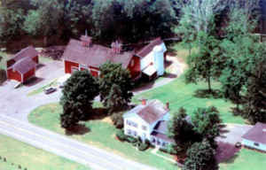

Here are a few residential comparables that have sold within the last year (2009 and 2010).

They are within 50 miles of our Historic Estate.

Some are on the water, some not. None have as much as the Estate with its 900’ water frontage, park-like setting, large outbuildings, wonderful location and in the heart of the Finger Lakes

Sold On: 07/09/2009 (36.6 miles from the Estate)

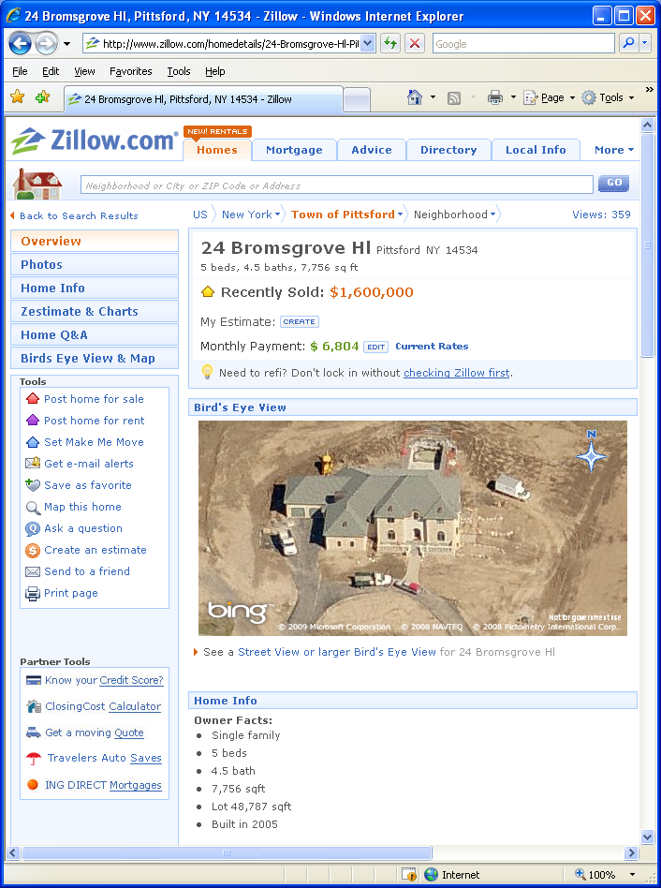

Sold On: 02/04/2010 (41.8 miles from the Estate)

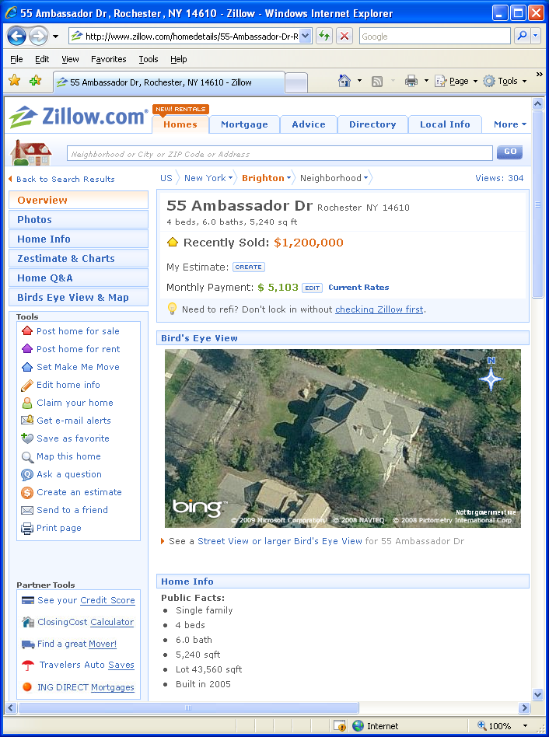

Sold On: 07/09/2009 (32.2 miles from the Estate)

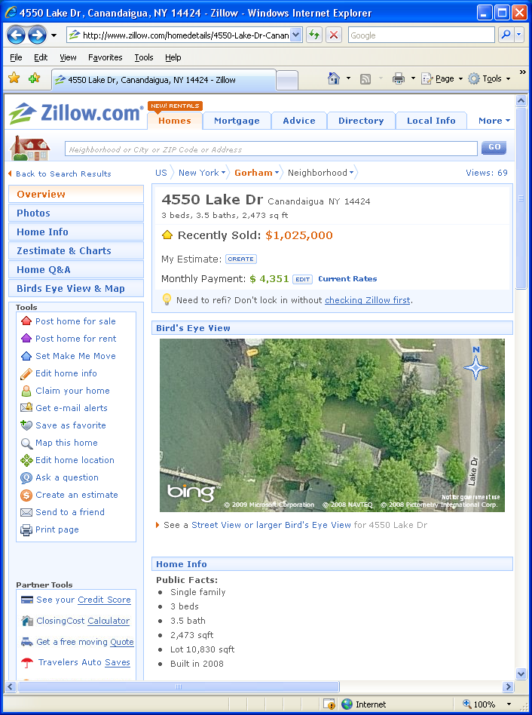

Sold On: 07/30/2009 (46.9 miles away)

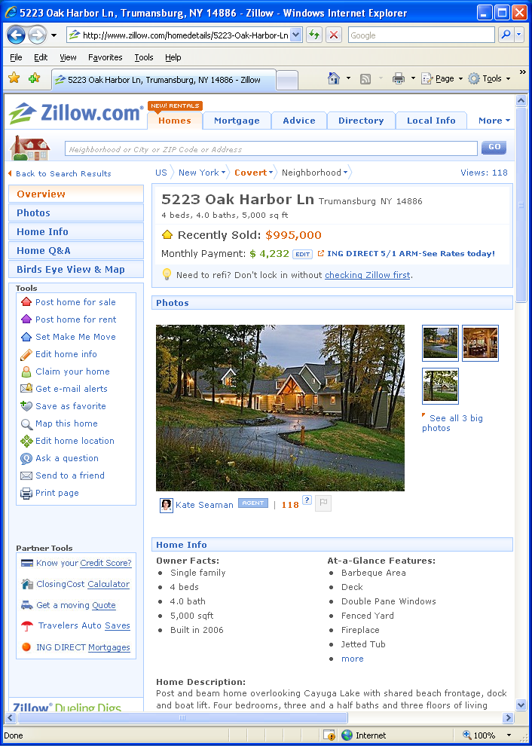

Sold On: 07/31/2009 (28.3 miles from the Estate)

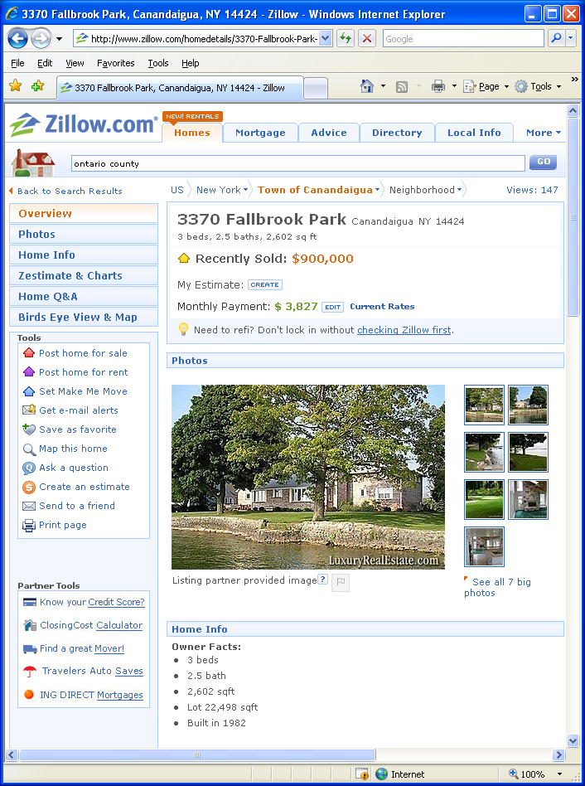
Sold On: 02/01/2010 (43.8 miles from the Estate)

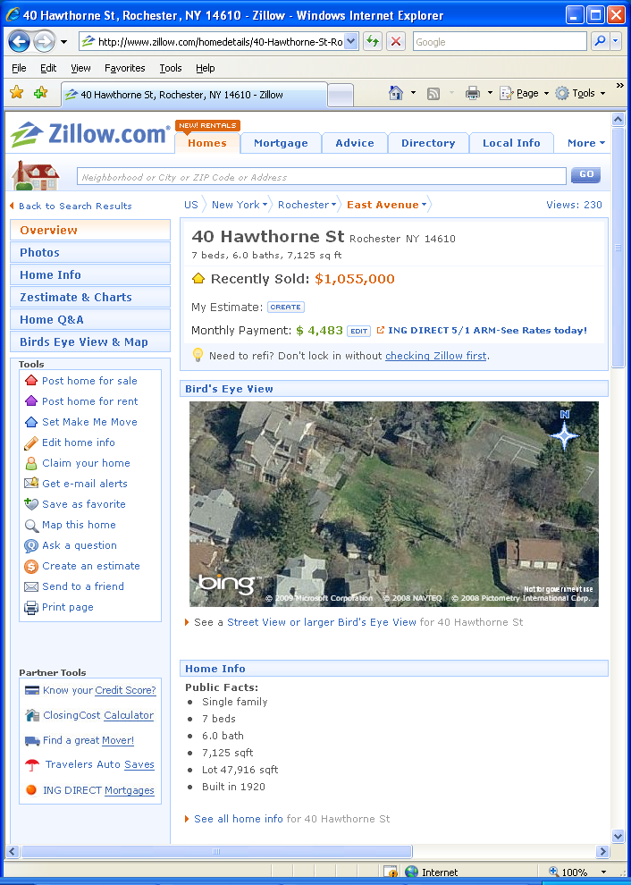
Sold On: 08/03/2009 (38.5 miles from the Estate)

